**GIT & INTELLIJ ASSIGNMENT**

1. **What is the use of the git add command?**

**Ans:-** The use of the git add command to tell Git which files I want to include in my next

commit. It prepares the changes to be saved.

1. **Write the command to create a branch “feature-group”.**

**Ans:-** The command to create a branch “feature-group” is **git branch feature-group**.

1. **What is a pull request? Write the steps involved in creating a pull request.**

**Ans:-** A pull request is when I ask to merge my changes into the main project.

**Steps: Push the code → Go to GitHub → Click “Compare & pull request” → Add**

**message → Click “Create pull request”.**

1. **How do you add collaborators?**

**Ans:-** I go to my GitHub repo → Click on "Settings" → Choose "Collaborators". Then I enter

their GitHub username and send an invite.

1. **What is the command used to commit our changes in github repo?**

**Ans:-** The command used to commit our changes in github repo is git commit -m "message".

1. **Create a github account and repository to save all your assignment tasks. Example repository name: rg-assignments**

Ans:- 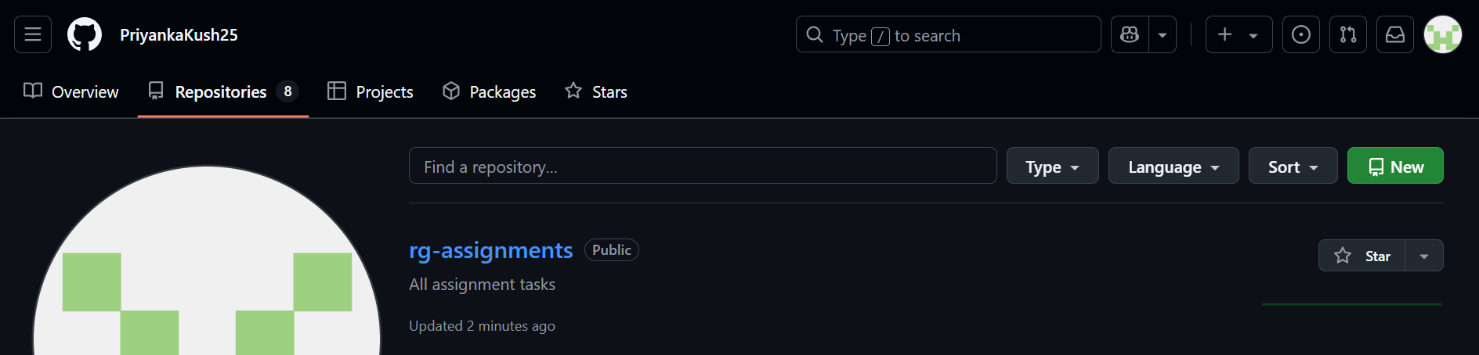

1. **Create a branch called feature-java(you can use it later to push all your java related tasks to this branch) .**

Ans:- 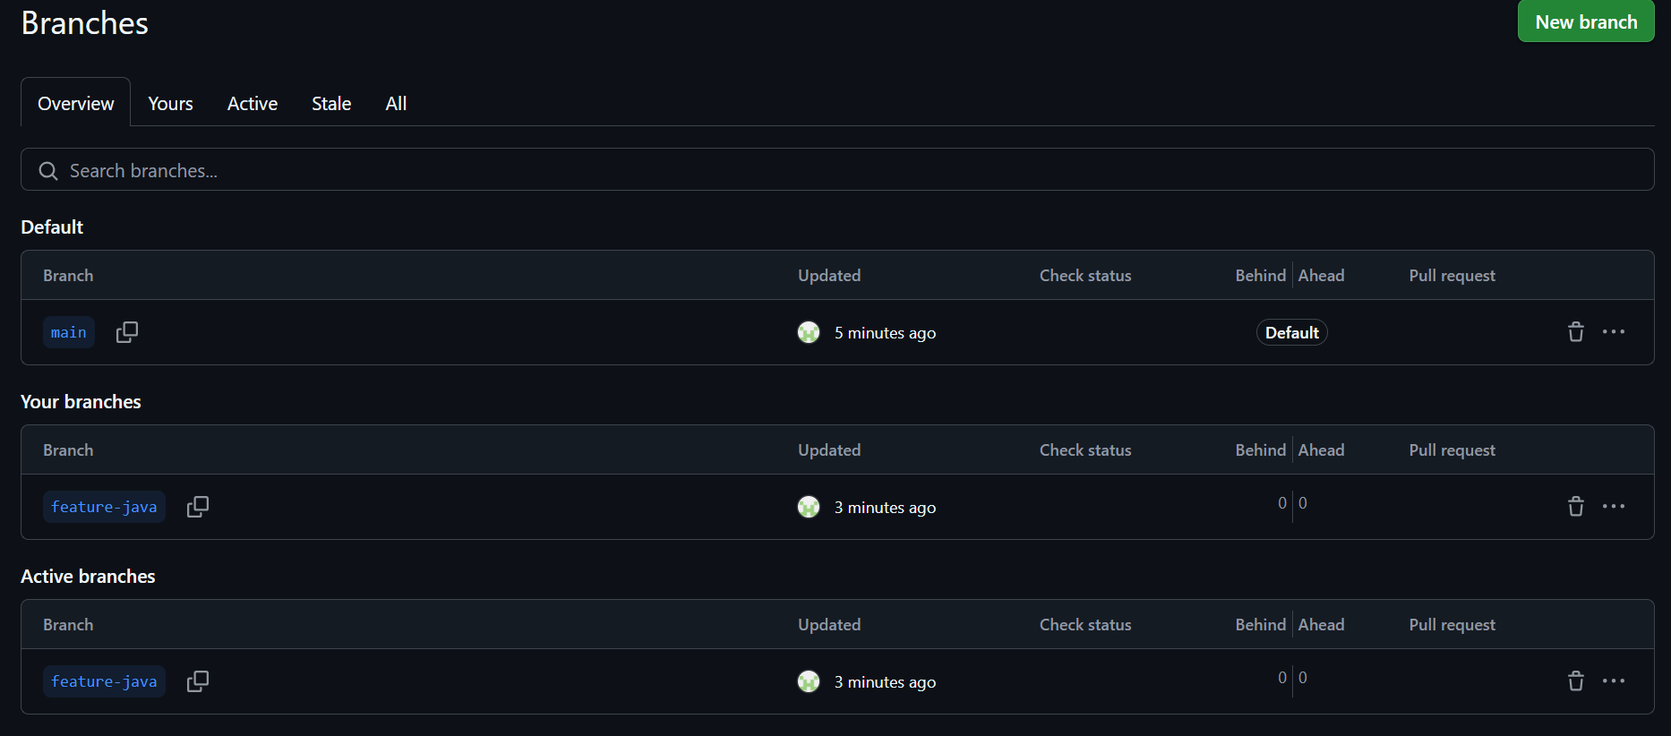

1. **Install IntelliJ IDE. Create a simple java project displaying “Hello World!!”and share the screenshot.**

Ans:- 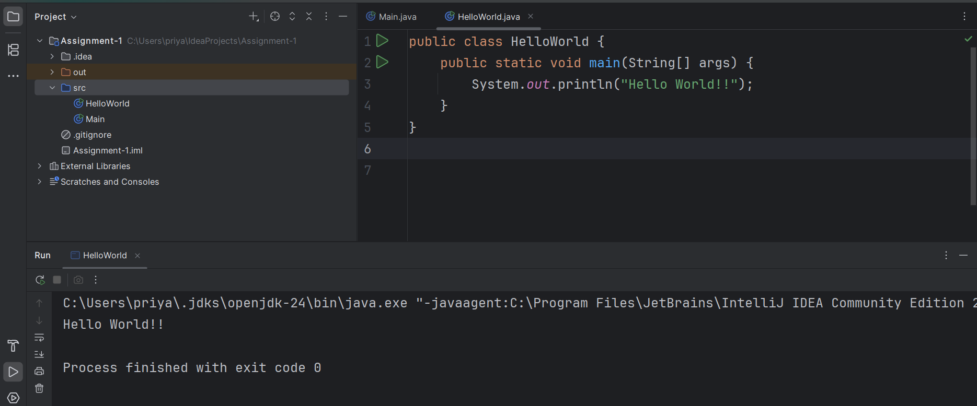

1. **In IntelliJ IDE, explore the shortcut keys for the following**
   1. **To run the project:-** Shift + F10
   2. **To select a line:-** Home → Shift + End
   3. **To comment/uncomment a line:-** Ctrl + /
   4. **To delete a line:-** Ctrl + Y

**Github Link:-**

<https://github.com/PriyankaKush25/Git-Intellij-Assignment>